# PSSM-SAA Builder

A demo program for getting a new feature expression named PSSM-SAA from protein sequences

User Manual

Shunfang Wang 1*¶, Wenjia Li 1¶, Yu Fei 2*, Zicheng Cao 1*, Dongshu Xu 1 and Huanyu Guo 3

1. Department of Computer Science and Engineering, School of Information Science and Engineering, Yunnan University, Kunming650504, PR China;
2. School of Statistics and Mathematics, Yunnan University of Finance and Economics, Kunming 650221, PR China; feiyukm@aliyun.com

3 Department of Communication Engineering, School of Information Science and Engineering, Yunnan University, Kunming 650504, PR China;

**Contect: caozichengtom@gmail.com;**

Version 1.0001

A New Feature Expression PSSM-SAA for Protein Subcellular Localization

Installations

1. Operating environment

PSSM-SAA Builder can work with any version of Windows that could support .NET Framework 3.5 or later. To install PSSM-SAA Builder on windows platform, the **.NET Framework 3.5 or later** **is required**. .NET Framework 3.5 can be download freely from the official site of Microsoft (<http://www.microsoft.com/net>)

To execute PSSM-SAA Builder from desktop, use explorer to open the PSSM-SAA Builder directory. Double-click Built-GUI icon or WindowsFormsApplication1.exe to execute the program.

1. Installation package

After users download the PSSM-SAA demo software from github, find the .exe file named setup，as the picture shows: , double-click the mouse to enter the software installation interface. As shown in **Fig 1.**

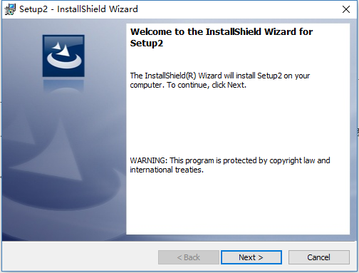

**Fig 1.**

Clicked **Next** to continue. Shown in **Fig 2.**

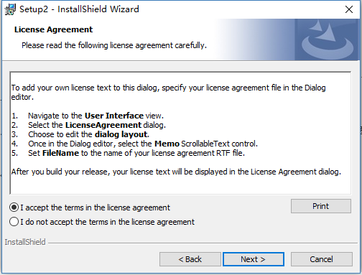

**Fig 2**

Choosing **I accept the terms in the license agreement**.and clicked **Next** to continue. Shown in **Fig 3.**

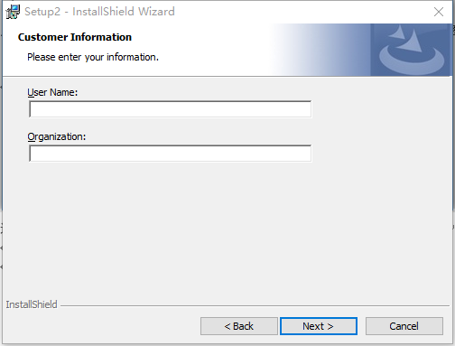

**Fig 3**

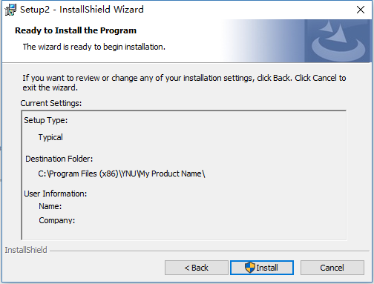

**Fig 4**

Clicked **Install** to enter the software installation：

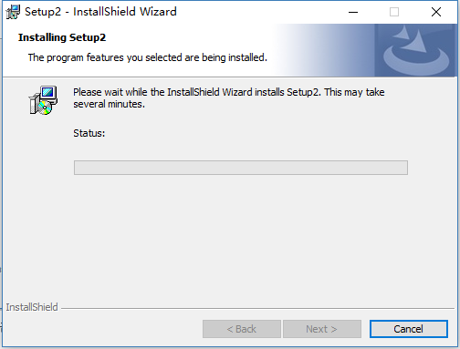

**Fig 5**

The interface after installation is shown in **Fig 6.**

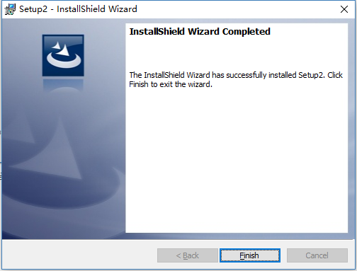

**Fig 6**

Clicked **Finsh**，finish installation.

After the software installation is completed, the installation path is **C:\Program Files (x86)\YNU\My Product Name\**

Double-click on the path or a shortcut like. Go to the demo software home page. As shown in **Fig 7**.

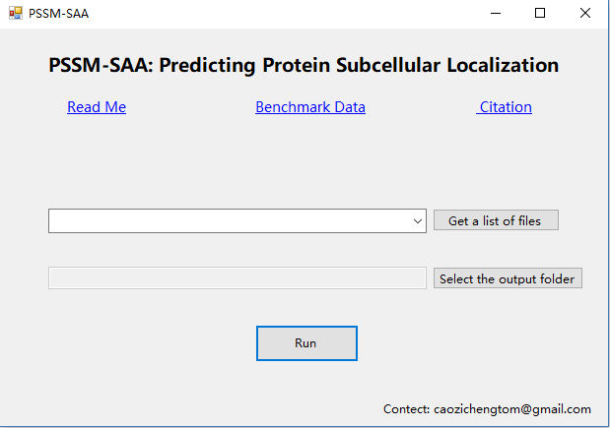

**Fig 7**

PSSM file input format

The prerequisite for the demonstration software to generate the PSSM-SAA sequence is that the PSSM matrix file has been generated using BLAST or other methods.As shown in **Fig 8.**

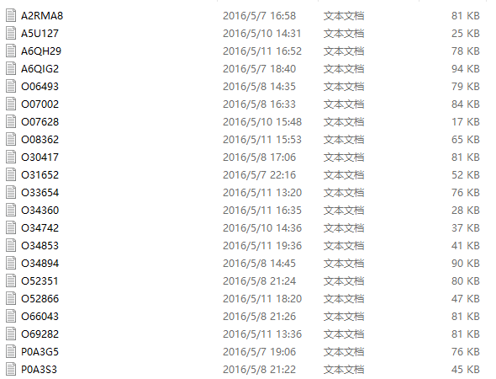

**Fig 8**

One of the file is shown in **Fig 9** below:

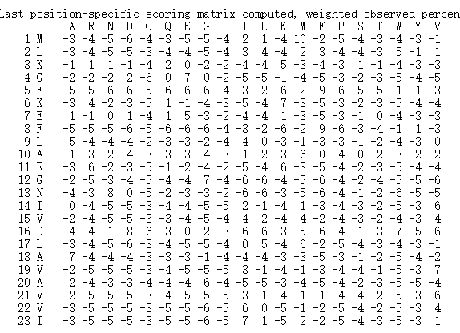

**Fig 9**

If you use the PSSM-SAA Builder demo software, you need to remove the first, second, and the end rows of the initial PSSM file. Moreover, removed the data matrix after 20 columns. Only keep each of the amino acid characters in the protein sequence and the top 20, which remember the processed PSSM file, like **Fig 10 .**

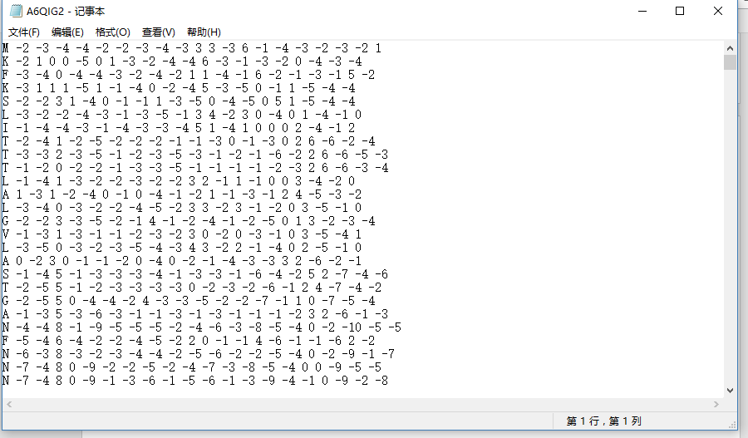

**Fig 10**

The processed PSSM file generates the PSSM-SAA file

Clicked the demo software a button named **Get a list of files** to select the processed PSSM file. Shown in **Fig 11**.

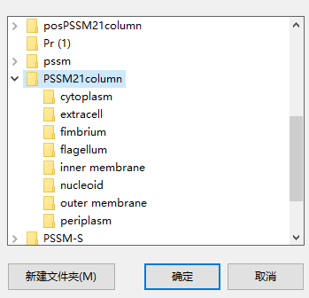

**Fig 11**

For example: We click on the reference protein sequence sample folder named **../Samples/PSSM21column** under a sub-nuclear cytoplasm folder, the demo software will load all the protein sequences in the current folder. Shown in **Fig 12**.

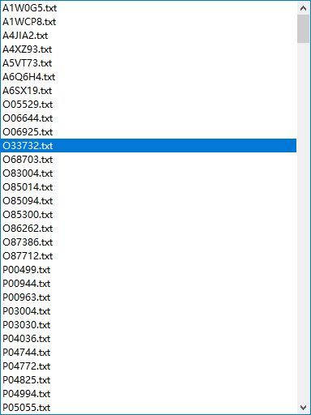

**Fig 12**

Clicked on a protein with PSSM feature sequence file as shown in **Fig 13**.

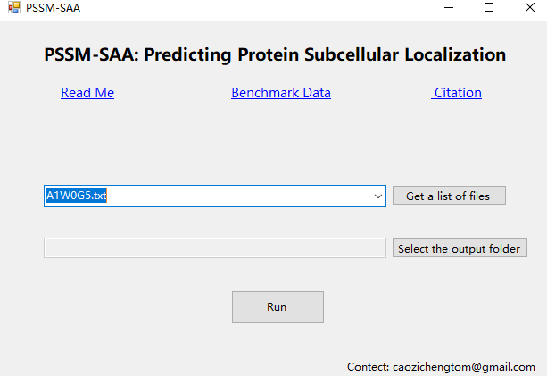

**Fig 13**

Clicked **Select the output folder** to select the custom PSSM-SAA folder as shown in **Fig 14.**



**Fig 14**

Clicked the button named **Run** to generate PSSM-SAA to complete, and then the demo software will automatically pop up the generated 1600-dimensional sequence file location.